Ideation Phase
Empathize & Discover

Date | 24 November 2025
Team ID
Project Name | Flight Booking App
Maximum Marks | 4 Marks

Empathy Map Canvas:
Passengers need a simple and reliable way to search and book flights because confusing interfaces, hidden charges, and unpredictable fares leave them feeling stressed, uncertain, and dissatisfied.
Airlines need a platform that efficiently connects their services to customers because poor visibility, inconsistent demand, and outdated booking systems make them feel restricted, inefficient, and unable to meet customer expectations.
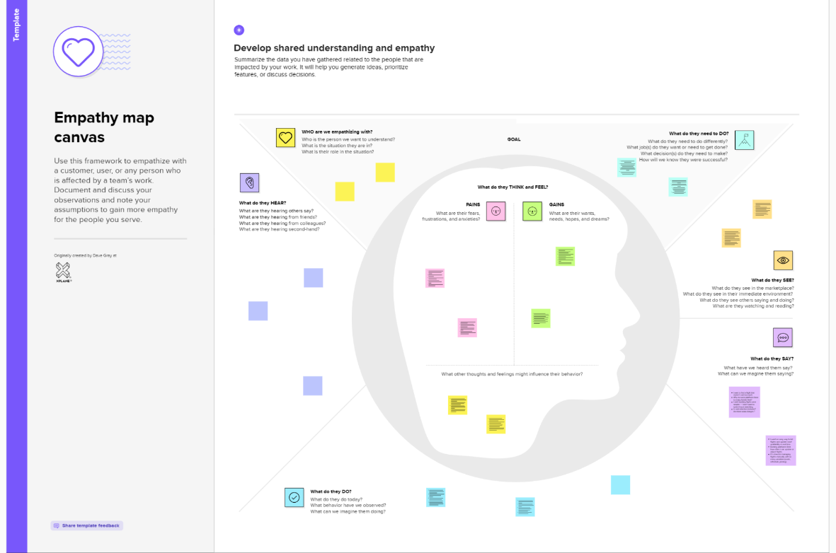

Reference: https://www.mural.co/templates/empathy-map-canvas

